**Code Documentation**

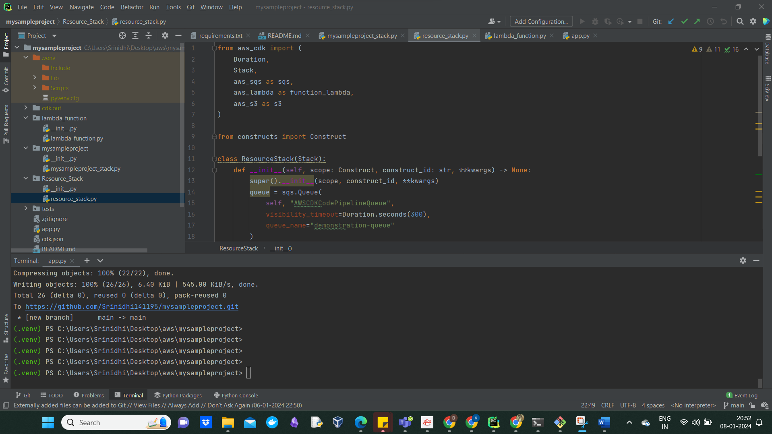

from aws_cdk import (

Duration,

Stack,

aws_sqs as sqs,

aws_lambda as function_lambda,

aws_s3 as s3

)

from constructs import Construct

class ResourceStack(Stack):

def __init__(self, scope: Construct, construct_id: str, **kwargs) -> None:

super().__init__(scope, construct_id, **kwargs)

queue = sqs.Queue(

self, "AWSCDKCodePipelineQueue",

visibility_timeout=Duration.seconds(300),

queue_name="demonstration-queue"

)

function = function_lambda.Function(self, "DemoCDKGITLambda",

function_name="CodePipeline_Lambda",

runtime=function_lambda.Runtime.PYTHON_3_10,

code=function_lambda.Code.from_asset('./lambda_function'),

handler="lambda_function.lambda_handler")

bucket = s3.Bucket(self, "MyFirstCDKBucket-Srinidhi", versioned = True,

bucket_name= "demo-bucket-srinidhi-acharla-cdk",

block_public_access=s3.BlockPublicAccess.BLOCK_ALL)

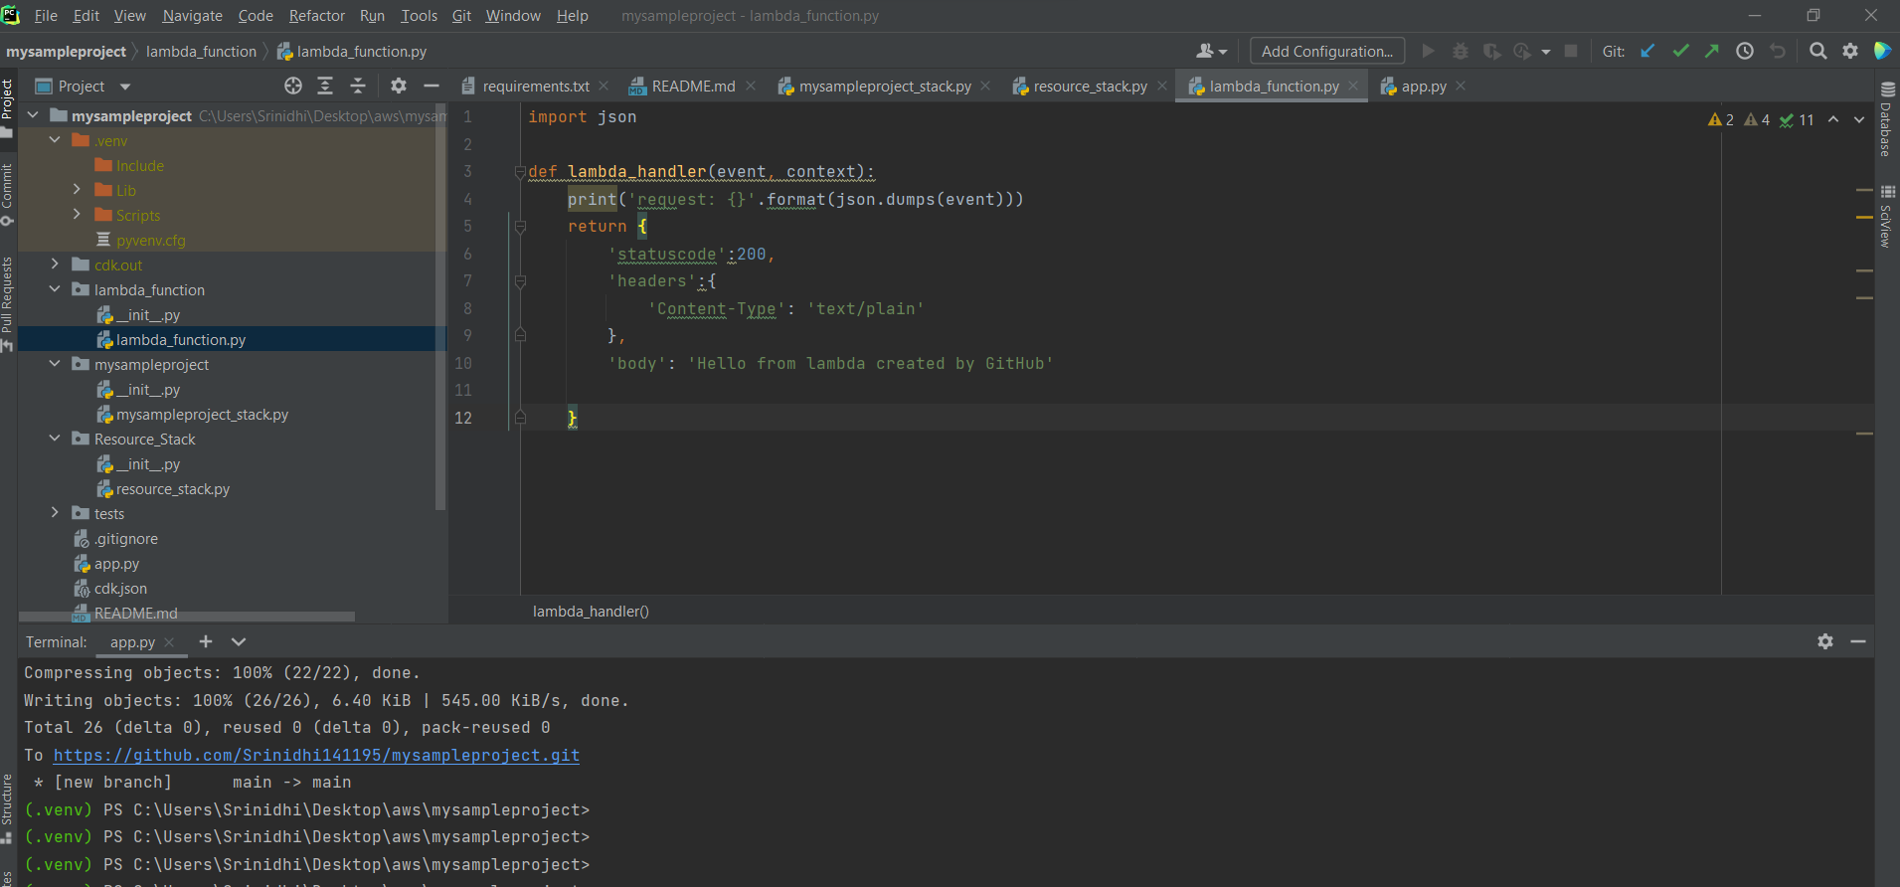

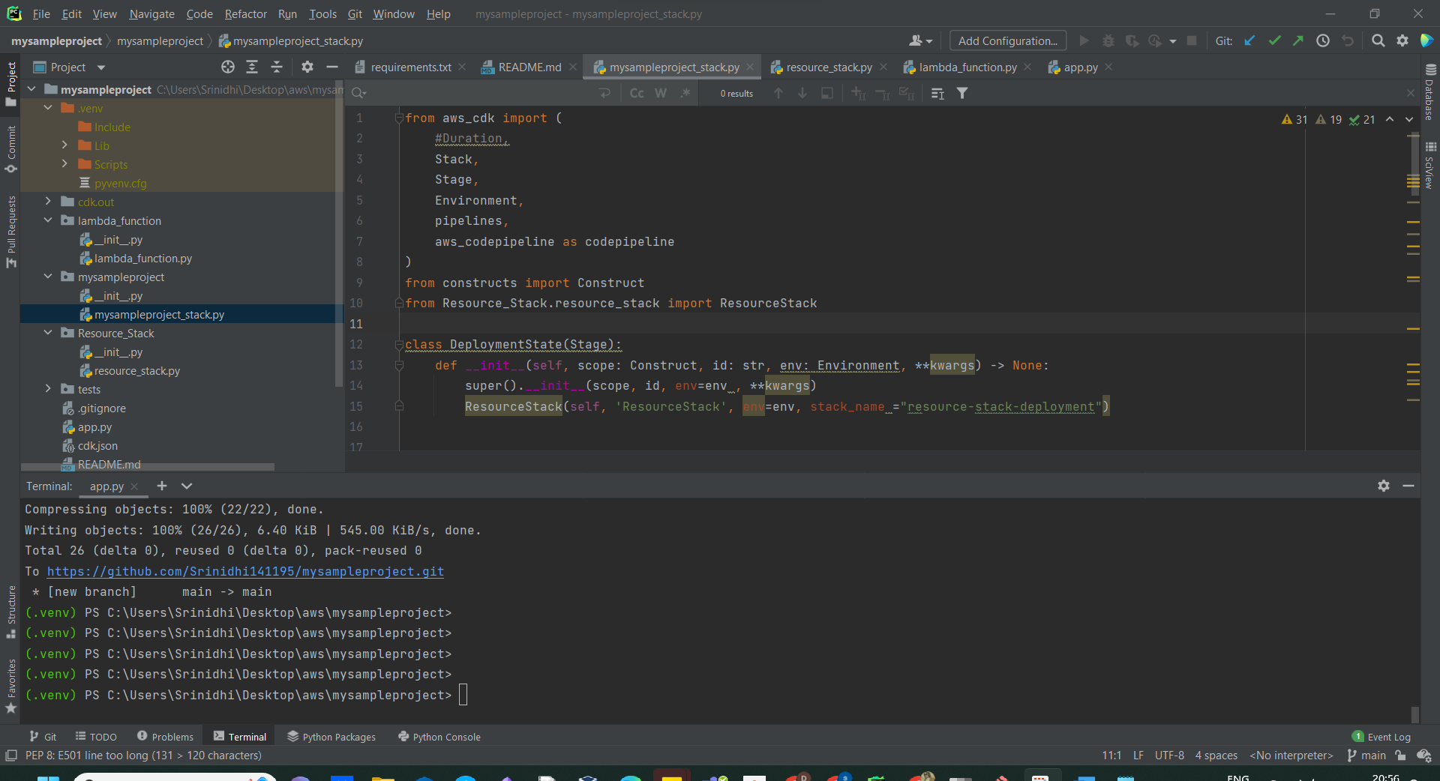

from aws_cdk import (

#Duration,

Stack,

Stage,

Environment,

pipelines,

aws_codepipeline as codepipeline

)

from constructs import Construct

from Resource_Stack.resource_stack import ResourceStack

class DeploymentState(Stage):

def __init__(self, scope: Construct, id: str, env: Environment, **kwargs) -> None:

super().__init__(scope, id, env=env , **kwargs)

ResourceStack(self, 'ResourceStack', env=env, stack_name ="resource-stack-deployment")

class MysampleprojectStack(Stack):

def __init__(self, scope: Construct, construct_id: str, **kwargs) -> None:

super().__init__(scope, construct_id, **kwargs)

git_input = pipelines.CodePipelineSource.connection(

repo_string="Srinidhi141195/mysampleproject",

branch="main",

connection_arn="arn:aws:codestar-connections:eu-central-1:545942567149:connection/eefa482c-920b-494c-983d-37ec8a2b007b"

)

code_pipeline = codepipeline.Pipeline(

self, "Pipeline",

pipeline_name ="new-pipeline",

cross_account_keys=False

)

synth_step =pipelines.ShellStep(

id ="Synth",

install_commands=[

'pip install -r requirements.txt'

],

commands=[

'npx cdk synth'

],

input=git_input

)

pipeline = pipelines.CodePipeline(

self, 'CodePipeline',

self_mutation=True,

code_pipeline=code_pipeline,

synth=synth_step

)

deployment_wave = pipeline.add_wave("DeploymentWave")

deployment_wave.add_stage(DeploymentState(

self, 'DeploymentStage',

env=(Environment(account='545942567149', region='eu-central-1'))

))

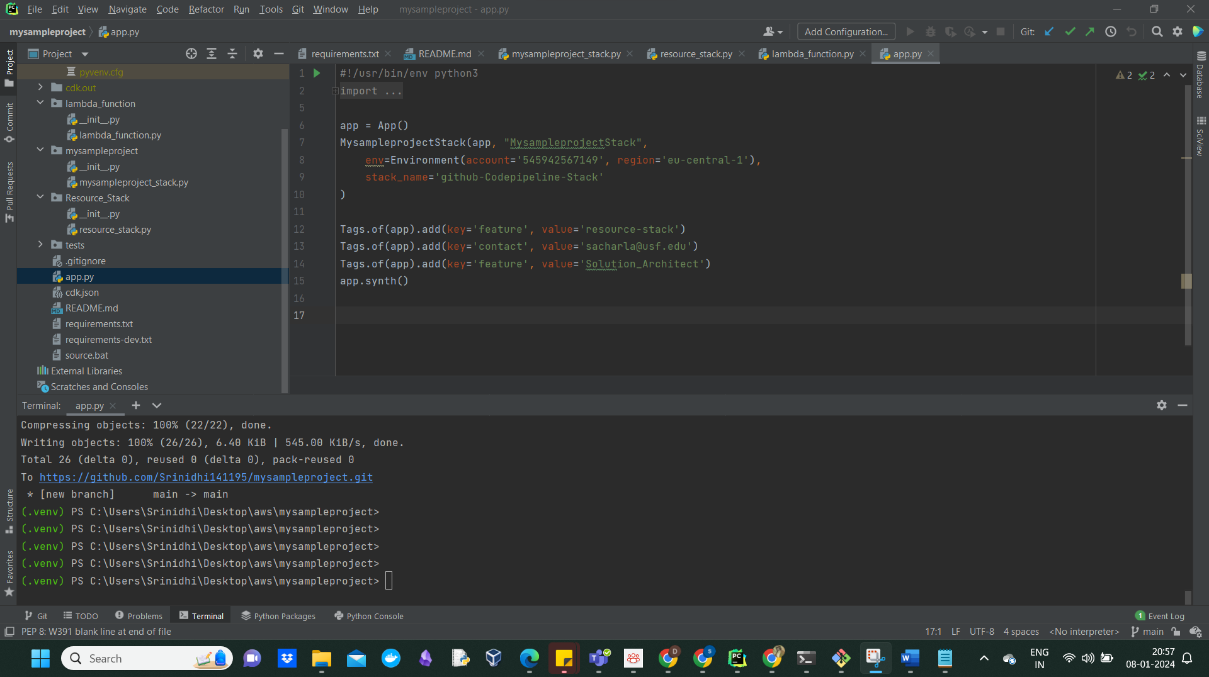

CDK synth:

(.venv) PS C:\Users\Srinidhi\Desktop\aws\mysampleproject> cdk synth

Resources:

PipelineArtifactsBucket22248F97:

Type: AWS::S3::Bucket

Properties:

BucketEncryption:

ServerSideEncryptionConfiguration:

- ServerSideEncryptionByDefault:

SSEAlgorithm: aws:kms

PublicAccessBlockConfiguration:

BlockPublicAcls: true

BlockPublicPolicy: true

IgnorePublicAcls: true

RestrictPublicBuckets: true

Tags:

- Key: contact

Value: sacharla@usf.edu

- Key: feature

Value: Solution_Architect

UpdateReplacePolicy: Retain

DeletionPolicy: Retain

Metadata:

aws:cdk:path: MysampleprojectStack/Pipeline/ArtifactsBucket/Resource

PipelineArtifactsBucketPolicyD4F9712A:

Type: AWS::S3::BucketPolicy

Properties:

Bucket:

Ref: PipelineArtifactsBucket22248F97

PolicyDocument:

Statement:

- Action: s3:*

Condition:

Bool:

aws:SecureTransport: "false"

Effect: Deny

Principal:

AWS: "*"

Resource:

- Fn::GetAtt:

- PipelineArtifactsBucket22248F97

- Arn

- Fn::Join:

- ""

- - Fn::GetAtt:

- PipelineArtifactsBucket22248F97

- Arn

- /*

- Action:

- s3:GetBucket*

- s3:GetObject*

- s3:List*

Effect: Allow

Principal:

AWS:

Fn::Join:

- ""

- - "arn:"

- Ref: AWS::Partition

- :iam::545942567149:role/cdk-hnb659fds-deploy-role-545942567149-eu-central-1

Resource:

- Fn::GetAtt:

- PipelineArtifactsBucket22248F97

- Arn

- Fn::Join:

- ""

- - Fn::GetAtt:

- PipelineArtifactsBucket22248F97

- Arn

- /*

Version: "2012-10-17"

Metadata:

aws:cdk:path: MysampleprojectStack/Pipeline/ArtifactsBucket/Policy/Resource

PipelineRoleD68726F7:

Type: AWS::IAM::Role

Properties:

AssumeRolePolicyDocument:

Statement:

- Action: sts:AssumeRole

Effect: Allow

Principal:

Service: codepipeline.amazonaws.com

Version: "2012-10-17"

Tags:

- Key: contact

Value: sacharla@usf.edu

- Key: feature

Value: Solution_Architect

Metadata:

aws:cdk:path: MysampleprojectStack/Pipeline/Role/Resource

PipelineRoleDefaultPolicyC7A05455:

Type: AWS::IAM::Policy

Properties:

PolicyDocument:

Statement:

- Action:

- s3:Abort*

- s3:DeleteObject*

- s3:GetBucket*

- s3:GetObject*

- s3:List*

- s3:PutObject

- s3:PutObjectLegalHold

- s3:PutObjectRetention

- s3:PutObjectTagging

- s3:PutObjectVersionTagging

Effect: Allow

Resource:

- Fn::GetAtt:

- PipelineArtifactsBucket22248F97

- Arn

- Fn::Join:

- ""

- - Fn::GetAtt:

- PipelineArtifactsBucket22248F97

- Arn

- /*

- Action: sts:AssumeRole

Effect: Allow

Resource:

- Fn::GetAtt:

- CodePipelineCodeBuildActionRole5942A84B

- Arn

- Fn::GetAtt:

- PipelineSourceSrinidhi141195mysampleprojectCodePipelineActionRoleB69617EC

- Arn

- Fn::Join:

- ""

- - "arn:"

- Ref: AWS::Partition

- :iam::545942567149:role/cdk-hnb659fds-deploy-role-545942567149-eu-central-1

Version: "2012-10-17"

PolicyName: PipelineRoleDefaultPolicyC7A05455

Roles:

- Ref: PipelineRoleD68726F7

Metadata:

aws:cdk:path: MysampleprojectStack/Pipeline/Role/DefaultPolicy/Resource

PipelineC660917D:

Type: AWS::CodePipeline::Pipeline

Properties:

ArtifactStore:

Location:

Ref: PipelineArtifactsBucket22248F97

Type: S3

Name: new-pipeline

RoleArn:

Fn::GetAtt:

- PipelineRoleD68726F7

- Arn

Stages:

- Actions:

- ActionTypeId:

Category: Source

Owner: AWS

Provider: CodeStarSourceConnection

Version: "1"

Configuration:

ConnectionArn: arn:aws:codestar-connections:eu-central-1:545942567149:connection/eefa482c-920b-494c-983d-37ec8a2b007b

FullRepositoryId: Srinidhi141195/mysampleproject

BranchName: main

Name: Srinidhi141195_mysampleproject

OutputArtifacts:

- Name: Srinidhi141195_mysampleproject_Source

RoleArn:

Fn::GetAtt:

- PipelineSourceSrinidhi141195mysampleprojectCodePipelineActionRoleB69617EC

- Arn

RunOrder: 1

Name: Source

- Actions:

- ActionTypeId:

Category: Build

Owner: AWS

Provider: CodeBuild

Version: "1"

Configuration:

ProjectName:

Ref: PipelineBuildSynthCdkBuildProject1250E181

EnvironmentVariables: '[{"name":"_PROJECT_CONFIG_HASH","type":"PLAINTEXT","value":"3e9990bbe90d0cbb72fd8fb924466036c7ae01662739ffc91d8093a824d041fc"}]'

InputArtifacts:

- Name: Srinidhi141195_mysampleproject_Source

Name: Synth

OutputArtifacts:

- Name: Synth_Output

RoleArn:

Fn::GetAtt:

- CodePipelineCodeBuildActionRole5942A84B

- Arn

RunOrder: 1

Name: Build

- Actions:

- ActionTypeId:

Category: Build

Owner: AWS

Provider: CodeBuild

Version: "1"

Configuration:

ProjectName:

Ref: CodePipelineUpdatePipelineSelfMutation6C493B1D

EnvironmentVariables: '[{"name":"_PROJECT_CONFIG_HASH","type":"PLAINTEXT","value":"08694f2eb6d028c3347d1a2e998b6ae2ddd2cecdd6b889dc544adb57fc65119f"}]'

InputArtifacts:

- Name: Synth_Output

Name: SelfMutate

RoleArn:

Fn::GetAtt:

- CodePipelineCodeBuildActionRole5942A84B

- Arn

RunOrder: 1

Name: UpdatePipeline

- Actions:

- ActionTypeId:

Category: Build

Owner: AWS

Provider: CodeBuild

Version: "1"

Configuration:

ProjectName:

Ref: CodePipelineAssetsFileAsset14467D1C5

InputArtifacts:

- Name: Synth_Output

Name: FileAsset1

RoleArn:

Fn::GetAtt:

- CodePipelineCodeBuildActionRole5942A84B

- Arn

RunOrder: 1

Name: Assets

- Actions:

- ActionTypeId:

Category: Deploy

Owner: AWS

Provider: CloudFormation

Version: "1"

Configuration:

StackName: resource-stack-deployment

Capabilities: CAPABILITY_NAMED_IAM,CAPABILITY_AUTO_EXPAND

RoleArn:

Fn::Join:

- ""

- - "arn:"

- Ref: AWS::Partition

- :iam::545942567149:role/cdk-hnb659fds-cfn-exec-role-545942567149-eu-central-1

ActionMode: CHANGE_SET_REPLACE

ChangeSetName: PipelineChange

TemplatePath: Synth_Output::assembly-MysampleprojectStack-DeploymentStage/MysampleprojectStackDeploymentStageResourceStack0FA6A0D6.template.json

InputArtifacts:

- Name: Synth_Output

Name: Prepare

RoleArn:

Fn::Join:

- ""

- - "arn:"

- Ref: AWS::Partition

- :iam::545942567149:role/cdk-hnb659fds-deploy-role-545942567149-eu-central-1

RunOrder: 1

- ActionTypeId:

Category: Deploy

Owner: AWS

Provider: CloudFormation

Version: "1"

Configuration:

StackName: resource-stack-deployment

ActionMode: CHANGE_SET_EXECUTE

ChangeSetName: PipelineChange

Name: Deploy

RoleArn:

Fn::Join:

- ""

- - "arn:"

- Ref: AWS::Partition

- :iam::545942567149:role/cdk-hnb659fds-deploy-role-545942567149-eu-central-1

RunOrder: 2

Name: DeploymentStage

Tags:

- Key: contact

Value: sacharla@usf.edu

- Key: feature

Value: Solution_Architect

DependsOn:

- PipelineRoleDefaultPolicyC7A05455

- PipelineRoleD68726F7

Metadata:

aws:cdk:path: MysampleprojectStack/Pipeline/Resource

PipelineSourceSrinidhi141195mysampleprojectCodePipelineActionRoleB69617EC:

Type: AWS::IAM::Role

Properties:

AssumeRolePolicyDocument:

Statement:

- Action: sts:AssumeRole

Effect: Allow

Principal:

AWS: arn:aws:iam::545942567149:root

Version: "2012-10-17"

Metadata:

aws:cdk:path: MysampleprojectStack/Pipeline/Source/Srinidhi141195_mysampleproject/CodePipelineActionRole/Resource

PipelineSourceSrinidhi141195mysampleprojectCodePipelineActionRoleDefaultPolicy81E471B2:

Type: AWS::IAM::Policy

Properties:

PolicyDocument:

Statement:

- Action: codestar-connections:UseConnection

Effect: Allow

Resource: arn:aws:codestar-connections:eu-central-1:545942567149:connection/eefa482c-920b-494c-983d-37ec8a2b007b

- Action:

- s3:Abort*

- s3:DeleteObject*

- s3:GetBucket*

- s3:GetObject*

- s3:List*

- s3:PutObject

- s3:PutObjectLegalHold

- s3:PutObjectRetention

- s3:PutObjectTagging

- s3:PutObjectVersionTagging

Effect: Allow

Resource:

- Fn::GetAtt:

- PipelineArtifactsBucket22248F97

- Arn

- Fn::Join:

- ""

- - Fn::GetAtt:

- PipelineArtifactsBucket22248F97

- Arn

- /*

- Action:

- s3:PutObjectAcl

- s3:PutObjectVersionAcl

Effect: Allow

Resource:

Fn::Join:

- ""

- - Fn::GetAtt:

- PipelineArtifactsBucket22248F97

- Arn

- /*

Version: "2012-10-17"

PolicyName: PipelineSourceSrinidhi141195mysampleprojectCodePipelineActionRoleDefaultPolicy81E471B2

Roles:

- Ref: PipelineSourceSrinidhi141195mysampleprojectCodePipelineActionRoleB69617EC

Metadata:

aws:cdk:path: MysampleprojectStack/Pipeline/Source/Srinidhi141195_mysampleproject/CodePipelineActionRole/DefaultPolicy/Resource

PipelineBuildSynthCdkBuildProjectRole808C155A:

Type: AWS::IAM::Role

Properties:

AssumeRolePolicyDocument:

Statement:

- Action: sts:AssumeRole

Effect: Allow

Principal:

Service: codebuild.amazonaws.com

Version: "2012-10-17"

Metadata:

aws:cdk:path: MysampleprojectStack/Pipeline/Build/Synth/CdkBuildProject/Role/Resource

PipelineBuildSynthCdkBuildProjectRoleDefaultPolicyE35C3CF9:

Type: AWS::IAM::Policy

Properties:

PolicyDocument:

Statement:

- Action:

- logs:CreateLogGroup

- logs:CreateLogStream

- logs:PutLogEvents

Effect: Allow

Resource:

- Fn::Join:

- ""

- - arn:aws:logs:eu-central-1:545942567149:log-group:/aws/codebuild/

- Ref: PipelineBuildSynthCdkBuildProject1250E181

- :*

- Fn::Join:

- ""

- - arn:aws:logs:eu-central-1:545942567149:log-group:/aws/codebuild/

- Ref: PipelineBuildSynthCdkBuildProject1250E181

- Action:

- codebuild:BatchPutCodeCoverages

- codebuild:BatchPutTestCases

- codebuild:CreateReport

- codebuild:CreateReportGroup

- codebuild:UpdateReport

Effect: Allow

Resource:

Fn::Join:

- ""

- - arn:aws:codebuild:eu-central-1:545942567149:report-group/

- Ref: PipelineBuildSynthCdkBuildProject1250E181

- -*

- Action:

- s3:Abort*

- s3:DeleteObject*

- s3:GetBucket*

- s3:GetObject*

- s3:List*

- s3:PutObject

- s3:PutObjectLegalHold

- s3:PutObjectRetention

- s3:PutObjectTagging

- s3:PutObjectVersionTagging

Effect: Allow

Resource:

- Fn::GetAtt:

- PipelineArtifactsBucket22248F97

- Arn

- Fn::Join:

- ""

- - Fn::GetAtt:

- PipelineArtifactsBucket22248F97

- Arn

- /*

Version: "2012-10-17"

PolicyName: PipelineBuildSynthCdkBuildProjectRoleDefaultPolicyE35C3CF9

Roles:

- Ref: PipelineBuildSynthCdkBuildProjectRole808C155A

Metadata:

aws:cdk:path: MysampleprojectStack/Pipeline/Build/Synth/CdkBuildProject/Role/DefaultPolicy/Resource

PipelineBuildSynthCdkBuildProject1250E181:

Type: AWS::CodeBuild::Project

Properties:

Artifacts:

Type: CODEPIPELINE

Cache:

Type: NO_CACHE

Description: Pipeline step github-Codepipeline-Stack/Pipeline/Build/Synth

EncryptionKey: alias/aws/s3

Environment:

ComputeType: BUILD_GENERAL1_SMALL

Image: aws/codebuild/standard:7.0

ImagePullCredentialsType: CODEBUILD

PrivilegedMode: false

Type: LINUX_CONTAINER

ServiceRole:

Fn::GetAtt:

- PipelineBuildSynthCdkBuildProjectRole808C155A

- Arn

Source:

BuildSpec: |-

{

"version": "0.2",

"phases": {

"install": {

"commands": [

"pip install -r requirements.txt"

]

},

"build": {

"commands": [

"npx cdk synth"

]

}

},

"artifacts": {

"base-directory": "cdk.out",

"files": "**/*"

}

}

Type: CODEPIPELINE

Metadata:

aws:cdk:path: MysampleprojectStack/Pipeline/Build/Synth/CdkBuildProject/Resource

CodePipelineCodeBuildActionRole5942A84B:

Type: AWS::IAM::Role

Properties:

AssumeRolePolicyDocument:

Statement:

- Action: sts:AssumeRole

Effect: Allow

Principal:

AWS:

Fn::GetAtt:

- PipelineRoleD68726F7

- Arn

Version: "2012-10-17"

Tags:

- Key: contact

Value: sacharla@usf.edu

- Key: feature

Value: Solution_Architect

Metadata:

aws:cdk:path: MysampleprojectStack/CodePipeline/CodeBuildActionRole/Resource

CodePipelineCodeBuildActionRoleDefaultPolicy36343F4C:

Type: AWS::IAM::Policy

Properties:

PolicyDocument:

Statement:

- Action:

- codebuild:BatchGetBuilds

- codebuild:StartBuild

- codebuild:StopBuild

Effect: Allow

Resource:

- Fn::GetAtt:

- CodePipelineAssetsFileAsset14467D1C5

- Arn

- Fn::GetAtt:

- CodePipelineUpdatePipelineSelfMutation6C493B1D

- Arn

- Fn::GetAtt:

- PipelineBuildSynthCdkBuildProject1250E181

- Arn

Version: "2012-10-17"

PolicyName: CodePipelineCodeBuildActionRoleDefaultPolicy36343F4C

Roles:

- Ref: CodePipelineCodeBuildActionRole5942A84B

Metadata:

aws:cdk:path: MysampleprojectStack/CodePipeline/CodeBuildActionRole/DefaultPolicy/Resource

CodePipelineUpdatePipelineSelfMutationRoleB367C8CE:

Type: AWS::IAM::Role

Properties:

AssumeRolePolicyDocument:

Statement:

- Action: sts:AssumeRole

Effect: Allow

Principal:

Service: codebuild.amazonaws.com

Version: "2012-10-17"

Tags:

- Key: contact

Value: sacharla@usf.edu

- Key: feature

Value: Solution_Architect

Metadata:

aws:cdk:path: MysampleprojectStack/CodePipeline/UpdatePipeline/SelfMutation/Role/Resource

CodePipelineUpdatePipelineSelfMutationRoleDefaultPolicyB9237C75:

Type: AWS::IAM::Policy

Properties:

PolicyDocument:

Statement:

- Action:

- logs:CreateLogGroup

- logs:CreateLogStream

- logs:PutLogEvents

Effect: Allow

Resource:

- Fn::Join:

- ""

- - arn:aws:logs:eu-central-1:545942567149:log-group:/aws/codebuild/

- Ref: CodePipelineUpdatePipelineSelfMutation6C493B1D

- :*

- Fn::Join:

- ""

- - arn:aws:logs:eu-central-1:545942567149:log-group:/aws/codebuild/

- Ref: CodePipelineUpdatePipelineSelfMutation6C493B1D

- Action:

- codebuild:BatchPutCodeCoverages

- codebuild:BatchPutTestCases

- codebuild:CreateReport

- codebuild:CreateReportGroup

- codebuild:UpdateReport

Effect: Allow

Resource:

Fn::Join:

- ""

- - arn:aws:codebuild:eu-central-1:545942567149:report-group/

- Ref: CodePipelineUpdatePipelineSelfMutation6C493B1D

- -*

- Action: sts:AssumeRole

Condition:

ForAnyValue:StringEquals:

iam:ResourceTag/aws-cdk:bootstrap-role:

- image-publishing

- file-publishing

- deploy

Effect: Allow

Resource: arn:*:iam::545942567149:role/*

- Action:

- cloudformation:DescribeStacks

- s3:ListBucket

Effect: Allow

Resource: "*"

- Action:

- s3:GetBucket*

- s3:GetObject*

- s3:List*

Effect: Allow

Resource:

- Fn::GetAtt:

- PipelineArtifactsBucket22248F97

- Arn

- Fn::Join:

- ""

- - Fn::GetAtt:

- PipelineArtifactsBucket22248F97

- Arn

- /*

Version: "2012-10-17"

PolicyName: CodePipelineUpdatePipelineSelfMutationRoleDefaultPolicyB9237C75

Roles:

- Ref: CodePipelineUpdatePipelineSelfMutationRoleB367C8CE

Metadata:

aws:cdk:path: MysampleprojectStack/CodePipeline/UpdatePipeline/SelfMutation/Role/DefaultPolicy/Resource

CodePipelineUpdatePipelineSelfMutation6C493B1D:

Type: AWS::CodeBuild::Project

Properties:

Artifacts:

Type: CODEPIPELINE

Cache:

Type: NO_CACHE

Description: Pipeline step github-Codepipeline-Stack/Pipeline/UpdatePipeline/SelfMutate

EncryptionKey: alias/aws/s3

Environment:

ComputeType: BUILD_GENERAL1_SMALL

Image: aws/codebuild/standard:7.0

ImagePullCredentialsType: CODEBUILD

PrivilegedMode: false

Type: LINUX_CONTAINER

ServiceRole:

Fn::GetAtt:

- CodePipelineUpdatePipelineSelfMutationRoleB367C8CE

- Arn

Source:

BuildSpec: |-

{

"version": "0.2",

"phases": {

"install": {

"commands": [

"npm install -g aws-cdk@2"

]

},

"build": {

"commands": [

"cdk -a . deploy MysampleprojectStack --require-approval=never --verbose"

]

}

}

}

Type: CODEPIPELINE

Tags:

- Key: contact

Value: sacharla@usf.edu

- Key: feature

Value: Solution_Architect

Metadata:

aws:cdk:path: MysampleprojectStack/CodePipeline/UpdatePipeline/SelfMutation/Resource

CodePipelineAssetsFileRole0AEE4A7F:

Type: AWS::IAM::Role

Properties:

AssumeRolePolicyDocument:

Statement:

- Action: sts:AssumeRole

Effect: Allow

Principal:

AWS: arn:aws:iam::545942567149:root

Service: codebuild.amazonaws.com

Version: "2012-10-17"

Tags:

- Key: contact

Value: sacharla@usf.edu

- Key: feature

Value: Solution_Architect

Metadata:

aws:cdk:path: MysampleprojectStack/CodePipeline/Assets/FileRole/Resource

CodePipelineAssetsFileRoleDefaultPolicy45357522:

Type: AWS::IAM::Policy

Properties:

PolicyDocument:

Statement:

- Action:

- logs:CreateLogGroup

- logs:CreateLogStream

- logs:PutLogEvents

Effect: Allow

Resource: arn:aws:logs:eu-central-1:545942567149:log-group:/aws/codebuild/*

- Action:

- codebuild:BatchPutCodeCoverages

- codebuild:BatchPutTestCases

- codebuild:CreateReport

- codebuild:CreateReportGroup

- codebuild:UpdateReport

Effect: Allow

Resource: arn:aws:codebuild:eu-central-1:545942567149:report-group/*

- Action:

- codebuild:BatchGetBuilds

- codebuild:StartBuild

- codebuild:StopBuild

Effect: Allow

Resource: "*"

- Action: sts:AssumeRole

Effect: Allow

Resource:

Fn::Sub: arn:${AWS::Partition}:iam::545942567149:role/cdk-hnb659fds-file-publishing-role-545942567149-eu-central-1

- Action:

- s3:GetBucket*

- s3:GetObject*

- s3:List*

Effect: Allow

Resource:

- Fn::GetAtt:

- PipelineArtifactsBucket22248F97

- Arn

- Fn::Join:

- ""

- - Fn::GetAtt:

- PipelineArtifactsBucket22248F97

- Arn

- /*

Version: "2012-10-17"

PolicyName: CodePipelineAssetsFileRoleDefaultPolicy45357522

Roles:

- Ref: CodePipelineAssetsFileRole0AEE4A7F

Metadata:

aws:cdk:path: MysampleprojectStack/CodePipeline/Assets/FileRole/DefaultPolicy/Resource

CodePipelineAssetsFileAsset14467D1C5:

Type: AWS::CodeBuild::Project

Properties:

Artifacts:

Type: CODEPIPELINE

Cache:

Type: NO_CACHE

Description: Pipeline step github-Codepipeline-Stack/Pipeline/Assets/FileAsset1

EncryptionKey: alias/aws/s3

Environment:

ComputeType: BUILD_GENERAL1_SMALL

Image: aws/codebuild/standard:7.0

ImagePullCredentialsType: CODEBUILD

PrivilegedMode: false

Type: LINUX_CONTAINER

ServiceRole:

Fn::GetAtt:

- CodePipelineAssetsFileRole0AEE4A7F

- Arn

Source:

BuildSpec: |-

{

"version": "0.2",

"phases": {

"install": {

"commands": [

"npm install -g cdk-assets@2"

]

},

"build": {

"commands": [

"cdk-assets --path \"assembly-MysampleprojectStack-DeploymentStage/MysampleprojectStackDeploymentStageResourceStack0FA6A0D6.assets.json\" --verbose publish \"3cc9e4c7

b6df8501540fbb4156adc0ab1454e35a15394a57414299210ed92a41:545942567149-eu-central-1\""

]

}

}

}

Type: CODEPIPELINE

Tags:

- Key: contact

Value: sacharla@usf.edu

- Key: feature

Value: Solution_Architect

Metadata:

aws:cdk:path: MysampleprojectStack/CodePipeline/Assets/FileAsset1/Resource

CDKMetadata:

Type: AWS::CDK::Metadata

Properties:

Analytics: v2:deflate64:H4sIAAAAAAAA/02OzQ6DIBCEn8U7brVeeq4vQOwDNAjbdBXBiMQYwrs3/hB7mm8nk525Q1k+oMjE4nKp+lxTC+E1C9kzsbh3kFbhSCNqMgiBn8Tqj0kcmasgPL3scd78kw7hVpNcL/u4IyMxQGis3j/tei

VTZqtuPWl19fLJdij3mhNjZA066yeJLO10UFuF/1tTJDK+zl9rbhWUBRRZ54jyyZuZBoTm0B9YO0stEgEAAA==

Metadata:

aws:cdk:path: MysampleprojectStack/CDKMetadata/Default

Parameters:

BootstrapVersion:

Type: AWS::SSM::Parameter::Value<String>

Default: /cdk-bootstrap/hnb659fds/version

Description: Version of the CDK Bootstrap resources in this environment, automatically retrieved from SSM Parameter Store. [cdk:skip]

Rules:

CheckBootstrapVersion:

Assertions:

- Assert:

Fn::Not:

- Fn::Contains:

- - "1"

- "2"

- "3"

- "4"

- "5"

- Ref: BootstrapVersion

AssertDescription: CDK bootstrap stack version 6 required. Please run 'cdk bootstrap' with a recent version of the CDK CLI.

(.venv) PS C:\Users\Srinidhi\Desktop\aws\mysampleproject> git add.

git: 'add.' is not a git command. See 'git --help'.

The most similar command is

add

(.venv) PS C:\Users\Srinidhi\Desktop\aws\mysampleproject> git add .

warning: in the working copy of '.gitignore', LF will be replaced by CRLF the next time Git touches it

warning: in the working copy of '.idea/inspectionProfiles/profiles_settings.xml', LF will be replaced by CRLF the next time Git touches it

warning: in the working copy of 'README.md', LF will be replaced by CRLF the next time Git touches it

warning: in the working copy of 'app.py', LF will be replaced by CRLF the next time Git touches it

warning: in the working copy of 'cdk.json', LF will be replaced by CRLF the next time Git touches it

warning: in the working copy of 'mysampleproject/mysampleproject_stack.py', LF will be replaced by CRLF the next time Git touches it

warning: in the working copy of 'requirements-dev.txt', LF will be replaced by CRLF the next time Git touches it

warning: in the working copy of 'requirements.txt', LF will be replaced by CRLF the next time Git touches it

warning: in the working copy of 'source.bat', LF will be replaced by CRLF the next time Git touches it

warning: in the working copy of 'tests/unit/test_mysampleproject_stack.py', LF will be replaced by CRLF the next time Git touches it

(.venv) PS C:\Users\Srinidhi\Desktop\aws\mysampleproject> git commit -m "first commit"

[main (root-commit) 9c21567] first commit

21 files changed, 333 insertions(+)

create mode 100644 .gitignore

create mode 100644 .idea/.gitignore

create mode 100644 .idea/inspectionProfiles/profiles_settings.xml

create mode 100644 .idea/modules.xml

create mode 100644 .idea/mysampleproject.iml

create mode 100644 .idea/vcs.xml

create mode 100644 README.md

create mode 100644 Resource_Stack/__init__.py

create mode 100644 Resource_Stack/resource_stack.py

create mode 100644 app.py

create mode 100644 cdk.json

create mode 100644 lambda_function/__init__.py

create mode 100644 lambda_function/lambda_function.py

create mode 100644 mysampleproject/__init__.py

create mode 100644 mysampleproject/mysampleproject_stack.py

create mode 100644 requirements-dev.txt

create mode 100644 requirements.txt

create mode 100644 source.bat

create mode 100644 tests/__init__.py

create mode 100644 tests/unit/__init__.py

create mode 100644 tests/unit/test_mysampleproject_stack.py

(.venv) PS C:\Users\Srinidhi\Desktop\aws\mysampleproject> git push

Enumerating objects: 26, done.

Counting objects: 100% (26/26), done.

Delta compression using up to 8 threads

Compressing objects: 100% (22/22), done.

Writing objects: 100% (26/26), 6.40 KiB | 545.00 KiB/s, done.

Total 26 (delta 0), reused 0 (delta 0), pack-reused 0

To https://github.com/Srinidhi141195/mysampleproject.git

* [new branch] main -> main

(.venv) PS C:\Users\Srinidhi\Desktop\aws\mysampleproject> cdk bootstrap

⏳ Bootstrapping environment aws://545942567149/eu-central-1...

Trusted accounts for deployment: (none)

Trusted accounts for lookup: (none)

Using default execution policy of 'arn:aws:iam::aws:policy/AdministratorAccess'. Pass '--cloudformation-execution-policies' to customize.

CDKToolkit: creating CloudFormation changeset...

CDKToolkit | 0/12 | 12:58:19 am | CREATE_IN_PROGRESS | AWS::S3::Bucket | StagingBucket Resource creation Initiated

CDKToolkit | 0/12 | 12:58:06 am | REVIEW_IN_PROGRESS | AWS::CloudFormation::Stack | CDKToolkit User Initiated

CDKToolkit | 0/12 | 12:58:13 am | CREATE_IN_PROGRESS | AWS::CloudFormation::Stack | CDKToolkit User Initiated

CDKToolkit | 0/12 | 12:58:16 am | CREATE_IN_PROGRESS | AWS::S3::Bucket | StagingBucket

CDKToolkit | 0/12 | 12:58:16 am | CREATE_IN_PROGRESS | AWS::IAM::Role | CloudFormationExecutionRole

CDKToolkit | 0/12 | 12:58:16 am | CREATE_IN_PROGRESS | AWS::ECR::Repository | ContainerAssetsRepository

CDKToolkit | 0/12 | 12:58:16 am | CREATE_IN_PROGRESS | AWS::SSM::Parameter | CdkBootstrapVersion

CDKToolkit | 0/12 | 12:58:16 am | CREATE_IN_PROGRESS | AWS::IAM::Role | ImagePublishingRole

CDKToolkit | 0/12 | 12:58:16 am | CREATE_IN_PROGRESS | AWS::IAM::Role | LookupRole

CDKToolkit | 0/12 | 12:58:16 am | CREATE_IN_PROGRESS | AWS::IAM::Role | FilePublishingRole

CDKToolkit | 0/12 | 12:58:17 am | CREATE_IN_PROGRESS | AWS::SSM::Parameter | CdkBootstrapVersion Resource creation Initiated

CDKToolkit | 0/12 | 12:58:17 am | CREATE_IN_PROGRESS | AWS::IAM::Role | FilePublishingRole Resource creation Initiated

CDKToolkit | 0/12 | 12:58:17 am | CREATE_IN_PROGRESS | AWS::IAM::Role | CloudFormationExecutionRole Resource creation Initiated

CDKToolkit | 0/12 | 12:58:17 am | CREATE_IN_PROGRESS | AWS::ECR::Repository | ContainerAssetsRepository Resource creation Initiated

CDKToolkit | 0/12 | 12:58:17 am | CREATE_IN_PROGRESS | AWS::IAM::Role | ImagePublishingRole Resource creation Initiated

CDKToolkit | 1/12 | 12:58:17 am | CREATE_COMPLETE | AWS::SSM::Parameter | CdkBootstrapVersion

CDKToolkit | 1/12 | 12:58:17 am | CREATE_IN_PROGRESS | AWS::IAM::Role | LookupRole Resource creation Initiated

CDKToolkit | 2/12 | 12:58:18 am | CREATE_COMPLETE | AWS::ECR::Repository | ContainerAssetsRepository

CDKToolkit | 3/12 | 12:58:35 am | CREATE_COMPLETE | AWS::IAM::Role | FilePublishingRole

CDKToolkit | 4/12 | 12:58:35 am | CREATE_COMPLETE | AWS::IAM::Role | ImagePublishingRole

CDKToolkit | 5/12 | 12:58:35 am | CREATE_COMPLETE | AWS::IAM::Role | CloudFormationExecutionRole

CDKToolkit | 6/12 | 12:58:35 am | CREATE_COMPLETE | AWS::IAM::Role | LookupRole

CDKToolkit | 6/12 | 12:58:36 am | CREATE_IN_PROGRESS | AWS::IAM::Policy | ImagePublishingRoleDefaultPolicy

CDKToolkit | 6/12 | 12:58:37 am | CREATE_IN_PROGRESS | AWS::IAM::Policy | ImagePublishingRoleDefaultPolicy Resource creation Initiated

CDKToolkit | 7/12 | 12:58:45 am | CREATE_COMPLETE | AWS::S3::Bucket | StagingBucket

CDKToolkit | 7/12 | 12:58:47 am | CREATE_IN_PROGRESS | AWS::IAM::Policy | FilePublishingRoleDefaultPolicy

CDKToolkit | 7/12 | 12:58:47 am | CREATE_IN_PROGRESS | AWS::S3::BucketPolicy | StagingBucketPolicy

CDKToolkit | 7/12 | 12:58:47 am | CREATE_IN_PROGRESS | AWS::IAM::Role | DeploymentActionRole

CDKToolkit | 7/12 | 12:58:48 am | CREATE_IN_PROGRESS | AWS::S3::BucketPolicy | StagingBucketPolicy Resource creation Initiated

CDKToolkit | 8/12 | 12:58:48 am | CREATE_COMPLETE | AWS::S3::BucketPolicy | StagingBucketPolicy

CDKToolkit | 8/12 | 12:58:49 am | CREATE_IN_PROGRESS | AWS::IAM::Policy | FilePublishingRoleDefaultPolicy Resource creation Initiated

CDKToolkit | 8/12 | 12:58:49 am | CREATE_IN_PROGRESS | AWS::IAM::Role | DeploymentActionRole Resource creation Initiated

CDKToolkit | 9/12 | 12:58:53 am | CREATE_COMPLETE | AWS::IAM::Policy | ImagePublishingRoleDefaultPolicy

CDKToolkit | 10/12 | 12:59:05 am | CREATE_COMPLETE | AWS::IAM::Policy | FilePublishingRoleDefaultPolicy

CDKToolkit | 11/12 | 12:59:07 am | CREATE_COMPLETE | AWS::IAM::Role | DeploymentActionRole

CDKToolkit | 12/12 | 12:59:09 am | CREATE_COMPLETE | AWS::CloudFormation::Stack | CDKToolkit

✅ Environment aws://545942567149/eu-central-1 bootstrapped.

(.venv) PS C:\Users\Srinidhi\Desktop\aws\mysampleproject> cdk deploy --require-approval never

✨ Synthesis time: 19.77s

github-Codepipeline-Stack: start: Building 0e3c524e13d2fdf9a223841e095b1a5b74cdc7c2effa112f88f21938ffe2c5a4:545942567149-eu-central-1

github-Codepipeline-Stack: success: Built 0e3c524e13d2fdf9a223841e095b1a5b74cdc7c2effa112f88f21938ffe2c5a4:545942567149-eu-central-1

github-Codepipeline-Stack: start: Publishing 0e3c524e13d2fdf9a223841e095b1a5b74cdc7c2effa112f88f21938ffe2c5a4:545942567149-eu-central-1

github-Codepipeline-Stack: success: Published 0e3c524e13d2fdf9a223841e095b1a5b74cdc7c2effa112f88f21938ffe2c5a4:545942567149-eu-central-1

MysampleprojectStack (github-Codepipeline-Stack): deploying... [1/1]

github-Codepipeline-Stack: creating CloudFormation changeset...

github-Codepipeline-Stack | 0/20 | 1:00:36 am | CREATE_IN_PROGRESS | AWS::CDK::Metadata | MysampleprojectStack/CDKMetadata/Default (CDKMetadata) Resource creation Initiated

github-Codepipeline-Stack | 1/20 | 1:00:36 am | CREATE_COMPLETE | AWS::CDK::Metadata | MysampleprojectStack/CDKMetadata/Default (CDKMetadata)

github-Codepipeline-Stack | 1/20 | 1:00:36 am | CREATE_IN_PROGRESS | AWS::IAM::Role | MysampleprojectStack/CodePipeline/UpdatePipeline/SelfMutation/Role (CodePipelineUpdatePipelineSelfMutationRoleB367C8CE) Resource creation Initiated

github-Codepipeline-Stack | 1/20 | 1:00:36 am | CREATE_IN_PROGRESS | AWS::IAM::Role | MysampleprojectStack/Pipeline/Source/Srinidhi141195_mysampleproject/CodePipelineActionRole (PipelineSourceSrinidhi141195mysampleprojectCodePipelineActionRoleB69617EC) Resource creation Initiated

github-Codepipeline-Stack | 1/20 | 1:00:36 am | CREATE_IN_PROGRESS | AWS::IAM::Role | MysampleprojectStack/CodePipeline/Assets/FileRole (CodePipelineAssetsFileRole0AEE4A7F) Resource creation Initiated

github-Codepipeline-Stack | 1/20 | 1:00:36 am | CREATE_IN_PROGRESS | AWS::IAM::Role | MysampleprojectStack/Pipeline/Role (PipelineRoleD68726F7) Resource creation Initiated

github-Codepipeline-Stack | 1/20 | 1:00:36 am | CREATE_IN_PROGRESS | AWS::IAM::Role | MysampleprojectStack/Pipeline/Build/Synth/CdkBuildProject/Role (PipelineBuildSynthCdkBuildProjectRole808C155A) Resource creation Initiated

github-Codepipeline-Stack | 1/20 | 1:00:17 am | REVIEW_IN_PROGRESS | AWS::CloudFormation::Stack | github-Codepipeline-Stack User Initiated

github-Codepipeline-Stack | 1/20 | 1:00:30 am | CREATE_IN_PROGRESS | AWS::CloudFormation::Stack | github-Codepipeline-Stack User Initiated

github-Codepipeline-Stack | 1/20 | 1:00:35 am | CREATE_IN_PROGRESS | AWS::CDK::Metadata | MysampleprojectStack/CDKMetadata/Default (CDKMetadata)

github-Codepipeline-Stack | 1/20 | 1:00:35 am | CREATE_IN_PROGRESS | AWS::S3::Bucket | MysampleprojectStack/Pipeline/ArtifactsBucket (PipelineArtifactsBucket22248F97)

github-Codepipeline-Stack | 1/20 | 1:00:35 am | CREATE_IN_PROGRESS | AWS::IAM::Role | MysampleprojectStack/CodePipeline/UpdatePipeline/SelfMutation/Role (CodePipelineUpdatePipelineSelfMutationRoleB367C8CE)

github-Codepipeline-Stack | 1/20 | 1:00:35 am | CREATE_IN_PROGRESS | AWS::IAM::Role | MysampleprojectStack/Pipeline/Role (PipelineRoleD68726F7)

github-Codepipeline-Stack | 1/20 | 1:00:35 am | CREATE_IN_PROGRESS | AWS::IAM::Role | MysampleprojectStack/Pipeline/Build/Synth/CdkBuildProject/Role (PipelineBuildSynthCdkBuildProjectRole808C155A)

github-Codepipeline-Stack | 1/20 | 1:00:35 am | CREATE_IN_PROGRESS | AWS::IAM::Role | MysampleprojectStack/CodePipeline/Assets/FileRole (CodePipelineAssetsFileRole0AEE4A7F)

github-Codepipeline-Stack | 1/20 | 1:00:35 am | CREATE_IN_PROGRESS | AWS::IAM::Role | MysampleprojectStack/Pipeline/Source/Srinidhi141195_mysampleproject/CodePipelineActionRole (PipelineSourceSrinidhi141195mysampleprojectCodePipelineActionRoleB69617EC)

github-Codepipeline-Stack | 1/20 | 1:00:38 am | CREATE_IN_PROGRESS | AWS::S3::Bucket | MysampleprojectStack/Pipeline/ArtifactsBucket (PipelineArtifactsBucket22248F97) Resource creation Initiated

github-Codepipeline-Stack | 2/20 | 1:00:52 am | CREATE_COMPLETE | AWS::IAM::Role | MysampleprojectStack/CodePipeline/UpdatePipeline/SelfMutation/Role (CodePipelineUpdatePipelineSelfMutationRoleB367C8CE)

github-Codepipeline-Stack | 3/20 | 1:00:53 am | CREATE_COMPLETE | AWS::IAM::Role | MysampleprojectStack/Pipeline/Role (PipelineRoleD68726F7)

github-Codepipeline-Stack | 4/20 | 1:00:53 am | CREATE_COMPLETE | AWS::IAM::Role | MysampleprojectStack/CodePipeline/Assets/FileRole (CodePipelineAssetsFileRole0AEE4A7F)

github-Codepipeline-Stack | 5/20 | 1:00:53 am | CREATE_COMPLETE | AWS::IAM::Role | MysampleprojectStack/Pipeline/Build/Synth/CdkBuildProject/Role (PipelineBuildSynthCdkBuildProjectRole808C155A)

github-Codepipeline-Stack | 6/20 | 1:00:53 am | CREATE_COMPLETE | AWS::IAM::Role | MysampleprojectStack/Pipeline/Source/Srinidhi141195_mysampleproject/CodePipelineActionRole (PipelineSourceSrinidhi141195mysampleprojectCodePipelineActionRoleB69617EC)

github-Codepipeline-Stack | 6/20 | 1:00:54 am | CREATE_IN_PROGRESS | AWS::CodeBuild::Project | MysampleprojectStack/CodePipeline/UpdatePipeline/SelfMutation (CodePipelineUpdatePipelineSelfMutation6C493B1D)

github-Codepipeline-Stack | 6/20 | 1:00:54 am | CREATE_IN_PROGRESS | AWS::IAM::Role | MysampleprojectStack/CodePipeline/CodeBuildActionRole (CodePipelineCodeBuildActionRole5942A84B)

github-Codepipeline-Stack | 6/20 | 1:00:54 am | CREATE_IN_PROGRESS | AWS::CodeBuild::Project | MysampleprojectStack/CodePipeline/Assets/FileAsset1 (CodePipelineAssetsFileAsset14467D1C5)

github-Codepipeline-Stack | 6/20 | 1:00:55 am | CREATE_IN_PROGRESS | AWS::CodeBuild::Project | MysampleprojectStack/Pipeline/Build/Synth/CdkBuildProject (PipelineBuildSynthCdkBuildProject1250E181)

github-Codepipeline-Stack | 6/20 | 1:00:56 am | CREATE_IN_PROGRESS | AWS::CodeBuild::Project | MysampleprojectStack/CodePipeline/UpdatePipeline/SelfMutation (CodePipelineUpdatePipelineSelfMutation6C493B1D) Resource creation Initiated

github-Codepipeline-Stack | 6/20 | 1:00:56 am | CREATE_IN_PROGRESS | AWS::IAM::Role | MysampleprojectStack/CodePipeline/CodeBuildActionRole (CodePipelineCodeBuildActionRole5942A84B) Resource creation Initiated

github-Codepipeline-Stack | 6/20 | 1:00:56 am | CREATE_IN_PROGRESS | AWS::CodeBuild::Project | MysampleprojectStack/CodePipeline/Assets/FileAsset1 (CodePipelineAssetsFileAsset14467D1C5) Resource creation Initiated

github-Codepipeline-Stack | 6/20 | 1:00:56 am | CREATE_IN_PROGRESS | AWS::CodeBuild::Project | MysampleprojectStack/Pipeline/Build/Synth/CdkBuildProject (PipelineBuildSynthCdkBuildProject1250E181) Resource creation Initiated

github-Codepipeline-Stack | 7/20 | 1:00:56 am | CREATE_COMPLETE | AWS::CodeBuild::Project | MysampleprojectStack/CodePipeline/UpdatePipeline/SelfMutation (CodePipelineUpdatePipelineSelfMutation6C493B1D)

github-Codepipeline-Stack | 8/20 | 1:00:56 am | CREATE_COMPLETE | AWS::CodeBuild::Project | MysampleprojectStack/CodePipeline/Assets/FileAsset1 (CodePipelineAssetsFileAsset14467D1C5)

github-Codepipeline-Stack | 9/20 | 1:00:56 am | CREATE_COMPLETE | AWS::CodeBuild::Project | MysampleprojectStack/Pipeline/Build/Synth/CdkBuildProject (PipelineBuildSynthCdkBuildProject1250E181)

github-Codepipeline-Stack | 10/20 | 1:01:03 am | CREATE_COMPLETE | AWS::S3::Bucket | MysampleprojectStack/Pipeline/ArtifactsBucket (PipelineArtifactsBucket22248F97)

github-Codepipeline-Stack | 10/20 | 1:01:06 am | CREATE_IN_PROGRESS | AWS::S3::BucketPolicy | MysampleprojectStack/Pipeline/ArtifactsBucket/Policy (PipelineArtifactsBucketPolicyD4F9712A)

github-Codepipeline-Stack | 10/20 | 1:01:06 am | CREATE_IN_PROGRESS | AWS::IAM::Policy | MysampleprojectStack/Pipeline/Build/Synth/CdkBuildProject/Role/DefaultPolicy (PipelineBuildSynthCdkBuildProjectRoleDefaultPolicyE35C3CF9)

github-Codepipeline-Stack | 10/20 | 1:01:06 am | CREATE_IN_PROGRESS | AWS::IAM::Policy | MysampleprojectStack/CodePipeline/UpdatePipeline/SelfMutation/Role/DefaultPolicy (CodePipelineUpdatePipelineSelfMutationRoleDefaultPolicyB9237C75)

github-Codepipeline-Stack | 10/20 | 1:01:06 am | CREATE_IN_PROGRESS | AWS::IAM::Policy | MysampleprojectStack/CodePipeline/Assets/FileRole/DefaultPolicy (CodePipelineAssetsFileRoleDefaultPolicy45357522)

github-Codepipeline-Stack | 10/20 | 1:01:06 am | CREATE_IN_PROGRESS | AWS::IAM::Policy | MysampleprojectStack/Pipeline/Source/Srinidhi141195_mysampleproject/CodePipelineActionRole/DefaultPolicy (PipelineSourceSrinidhi141195mysampleprojectCodePipelineActionRoleDefaultPolicy81E471B2)

github-Codepipeline-Stack | 10/20 | 1:01:07 am | CREATE_IN_PROGRESS | AWS::S3::BucketPolicy | MysampleprojectStack/Pipeline/ArtifactsBucket/Policy (PipelineArtifactsBucketPolicyD4F9712A) Resource creation Initiated

github-Codepipeline-Stack | 10/20 | 1:01:08 am | CREATE_IN_PROGRESS | AWS::IAM::Policy | MysampleprojectStack/CodePipeline/UpdatePipeline/SelfMutation/Role/DefaultPolicy (CodePipelineUpdatePipelineSelfMutationRoleDefaultPolicyB9237C75) Resource creation Initiated

github-Codepipeline-Stack | 11/20 | 1:01:08 am | CREATE_COMPLETE | AWS::S3::BucketPolicy | MysampleprojectStack/Pipeline/ArtifactsBucket/Policy (PipelineArtifactsBucketPolicyD4F9712A)

github-Codepipeline-Stack | 11/20 | 1:01:08 am | CREATE_IN_PROGRESS | AWS::IAM::Policy | MysampleprojectStack/Pipeline/Build/Synth/CdkBuildProject/Role/DefaultPolicy (PipelineBuildSynthCdkBuildProjectRoleDefaultPolicyE35C3CF9) Resource creation Initiated

github-Codepipeline-Stack | 11/20 | 1:01:08 am | CREATE_IN_PROGRESS | AWS::IAM::Policy | MysampleprojectStack/Pipeline/Source/Srinidhi141195_mysampleproject/CodePipelineActionRole/DefaultPolicy (PipelineSourceSrinidhi141195mysampleprojectCodePipelineActionRoleDefaultPolicy81E471B2) Resource creation Initiated

github-Codepipeline-Stack | 11/20 | 1:01:08 am | CREATE_IN_PROGRESS | AWS::IAM::Policy | MysampleprojectStack/CodePipeline/Assets/FileRole/DefaultPolicy (CodePipelineAssetsFileRoleDefaultPolicy45357522) Resource creation Initiated

github-Codepipeline-Stack | 12/20 | 1:01:12 am | CREATE_COMPLETE | AWS::IAM::Role | MysampleprojectStack/CodePipeline/CodeBuildActionRole (CodePipelineCodeBuildActionRole5942A84B)

github-Codepipeline-Stack | 12/20 | 1:01:14 am | CREATE_IN_PROGRESS | AWS::IAM::Policy | MysampleprojectStack/CodePipeline/CodeBuildActionRole/DefaultPolicy (CodePipelineCodeBuildActionRoleDefaultPolicy36343F4C)

github-Codepipeline-Stack | 12/20 | 1:01:15 am | CREATE_IN_PROGRESS | AWS::IAM::Policy | MysampleprojectStack/Pipeline/Role/DefaultPolicy (PipelineRoleDefaultPolicyC7A05455)

github-Codepipeline-Stack | 12/20 | 1:01:15 am | CREATE_IN_PROGRESS | AWS::IAM::Policy | MysampleprojectStack/CodePipeline/CodeBuildActionRole/DefaultPolicy (CodePipelineCodeBuildActionRoleDefaultPolicy36343F4C) Resource creation Initiated

github-Codepipeline-Stack | 12/20 | 1:01:17 am | CREATE_IN_PROGRESS | AWS::IAM::Policy | MysampleprojectStack/Pipeline/Role/DefaultPolicy (PipelineRoleDefaultPolicyC7A05455) Resource creation Initiated

github-Codepipeline-Stack | 13/20 | 1:01:23 am | CREATE_COMPLETE | AWS::IAM::Policy | MysampleprojectStack/CodePipeline/UpdatePipeline/SelfMutation/Role/DefaultPolicy (CodePipelineUpdatePipelineSelfMutationRoleDefaultPolicyB9237C75)

github-Codepipeline-Stack | 14/20 | 1:01:24 am | CREATE_COMPLETE | AWS::IAM::Policy | MysampleprojectStack/Pipeline/Build/Synth/CdkBuildProject/Role/DefaultPolicy (PipelineBuildSynthCdkBuildProjectRoleDefaultPolicyE35C3CF9)

github-Codepipeline-Stack | 15/20 | 1:01:24 am | CREATE_COMPLETE | AWS::IAM::Policy | MysampleprojectStack/Pipeline/Source/Srinidhi141195_mysampleproject/CodePipelineActionRole/DefaultPolicy (PipelineSourceSrinidhi141195mysampleprojectCodePipelineActionRoleDefaultPolicy81E471B2)

github-Codepipeline-Stack | 16/20 | 1:01:24 am | CREATE_COMPLETE | AWS::IAM::Policy | MysampleprojectStack/CodePipeline/Assets/FileRole/DefaultPolicy (CodePipelineAssetsFileRoleDefaultPolicy45357522)

github-Codepipeline-Stack | 17/20 | 1:01:31 am | CREATE_COMPLETE | AWS::IAM::Policy | MysampleprojectStack/CodePipeline/CodeBuildActionRole/DefaultPolicy (CodePipelineCodeBuildActionRoleDefaultPolicy36343F4C)

github-Codepipeline-Stack | 18/20 | 1:01:33 am | CREATE_COMPLETE | AWS::IAM::Policy | MysampleprojectStack/Pipeline/Role/DefaultPolicy (PipelineRoleDefaultPolicyC7A05455)

github-Codepipeline-Stack | 18/20 | 1:01:36 am | CREATE_IN_PROGRESS | AWS::CodePipeline::Pipeline | MysampleprojectStack/Pipeline (PipelineC660917D)

github-Codepipeline-Stack | 18/20 | 1:01:37 am | CREATE_IN_PROGRESS | AWS::CodePipeline::Pipeline | MysampleprojectStack/Pipeline (PipelineC660917D) Resource creation Initiated

github-Codepipeline-Stack | 19/20 | 1:01:38 am | CREATE_COMPLETE | AWS::CodePipeline::Pipeline | MysampleprojectStack/Pipeline (PipelineC660917D)

github-Codepipeline-Stack | 20/20 | 1:01:39 am | CREATE_COMPLETE | AWS::CloudFormation::Stack | github-Codepipeline-Stack

✅ MysampleprojectStack (github-Codepipeline-Stack)

✨ Deployment time: 90.31s

Stack ARN:

arn:aws:cloudformation:eu-central-1:545942567149:stack/github-Codepipeline-Stack/0824b220-ad22-11ee-8db9-0ae6e9aebc39

✨ Total time: 110.08s

(.venv) PS C:\Users\Srinidhi\Desktop\aws\mysampleproject>

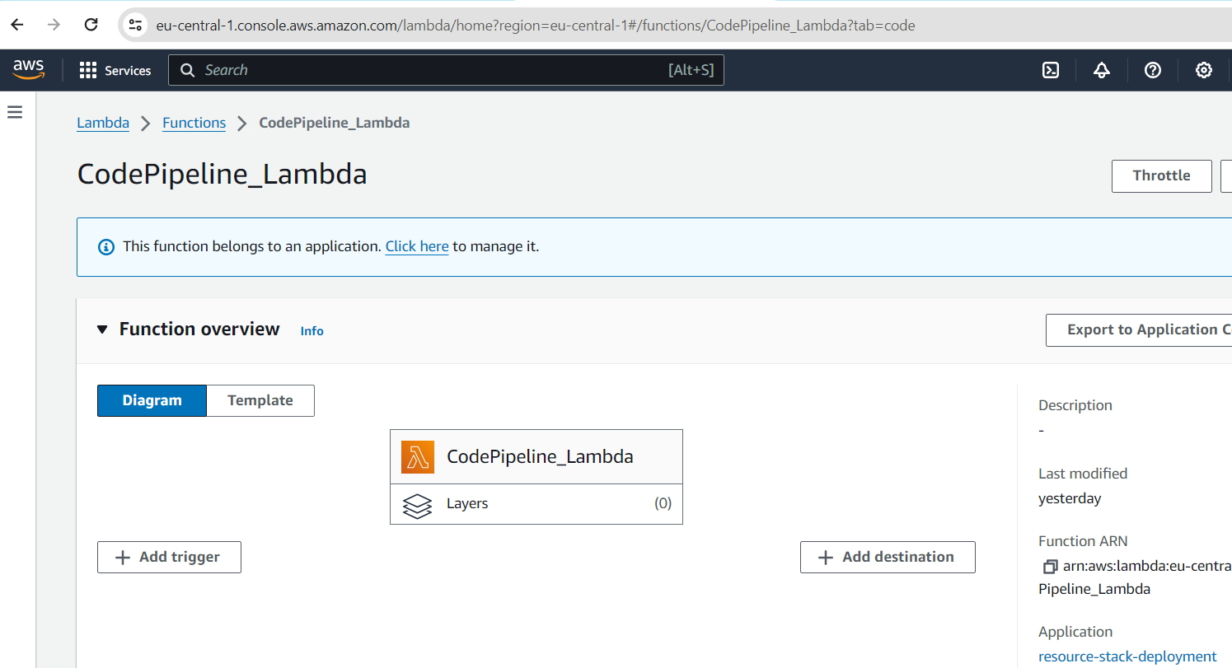

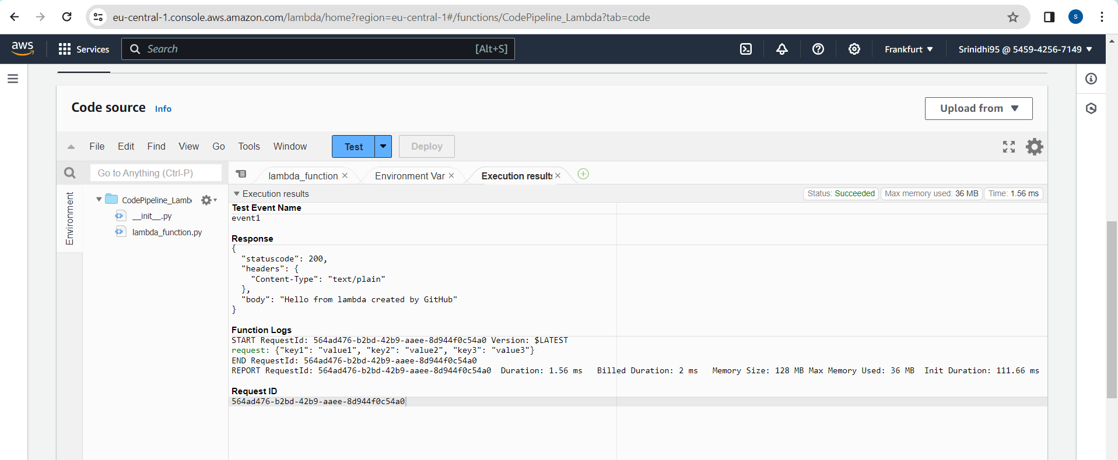

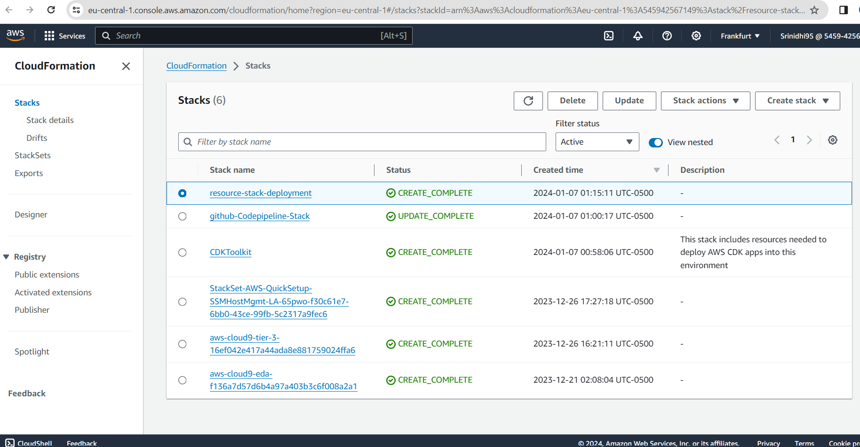

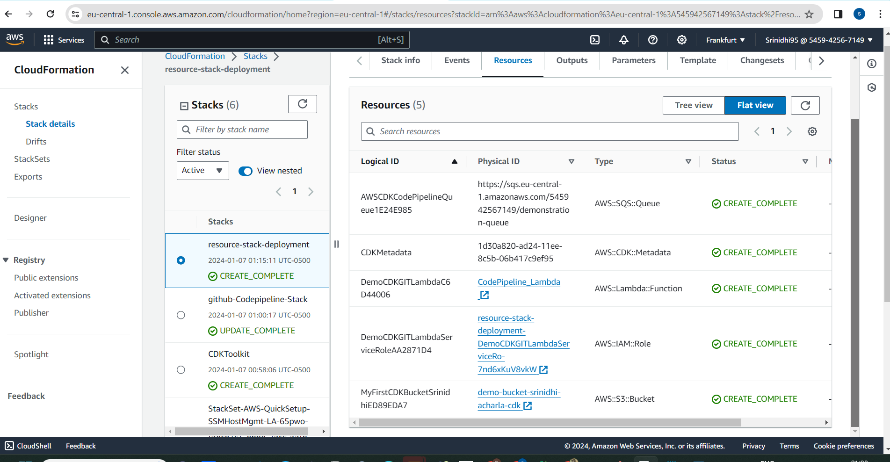

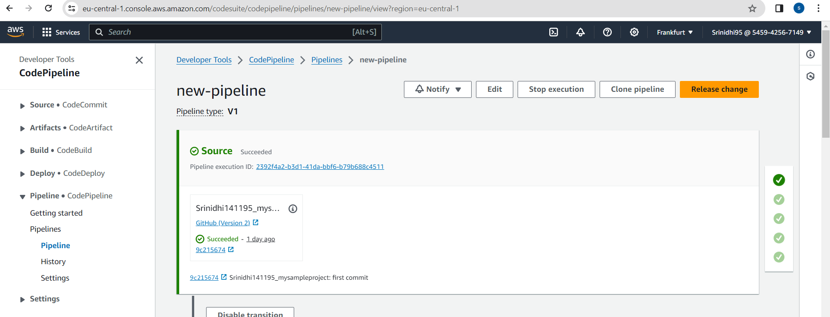

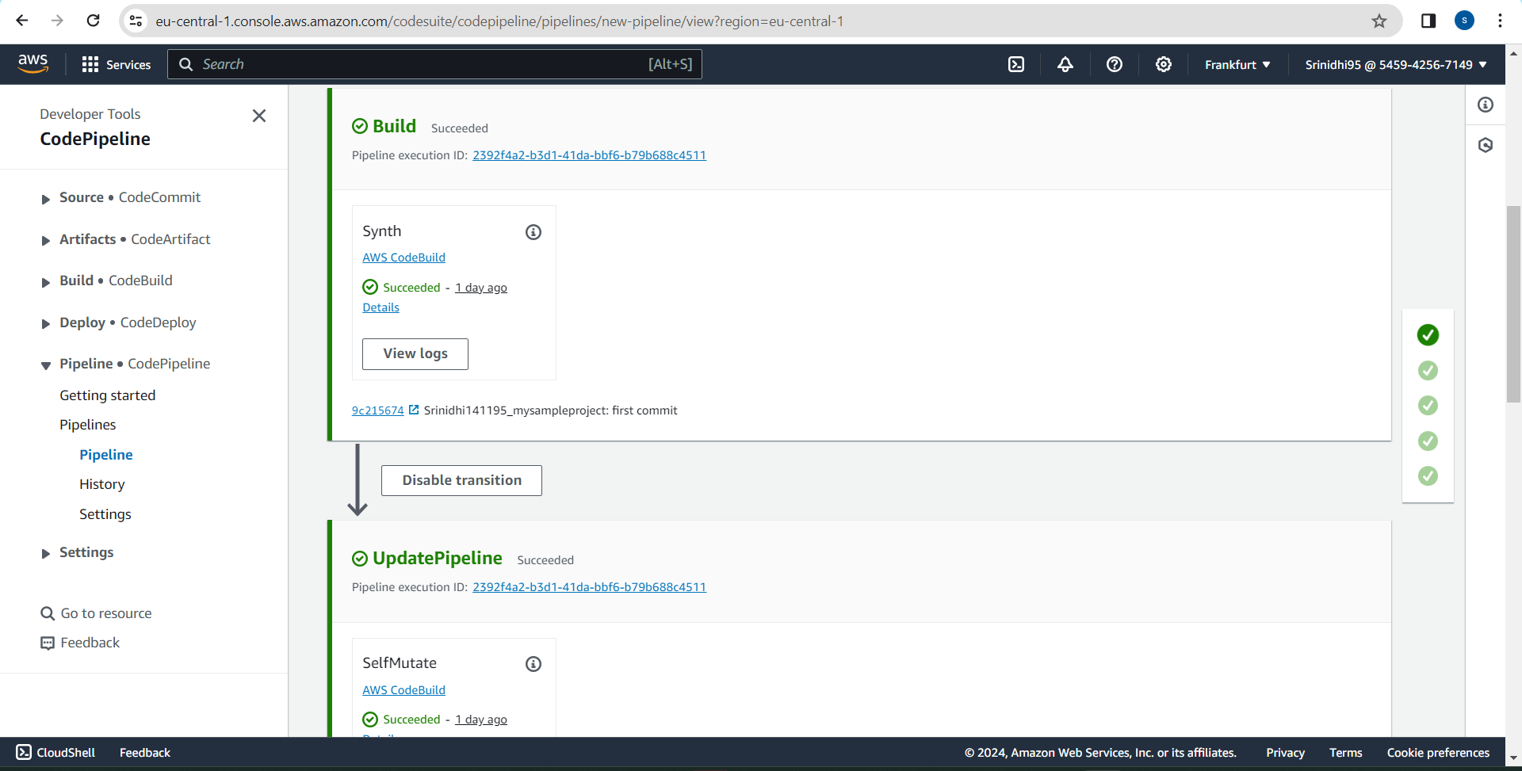

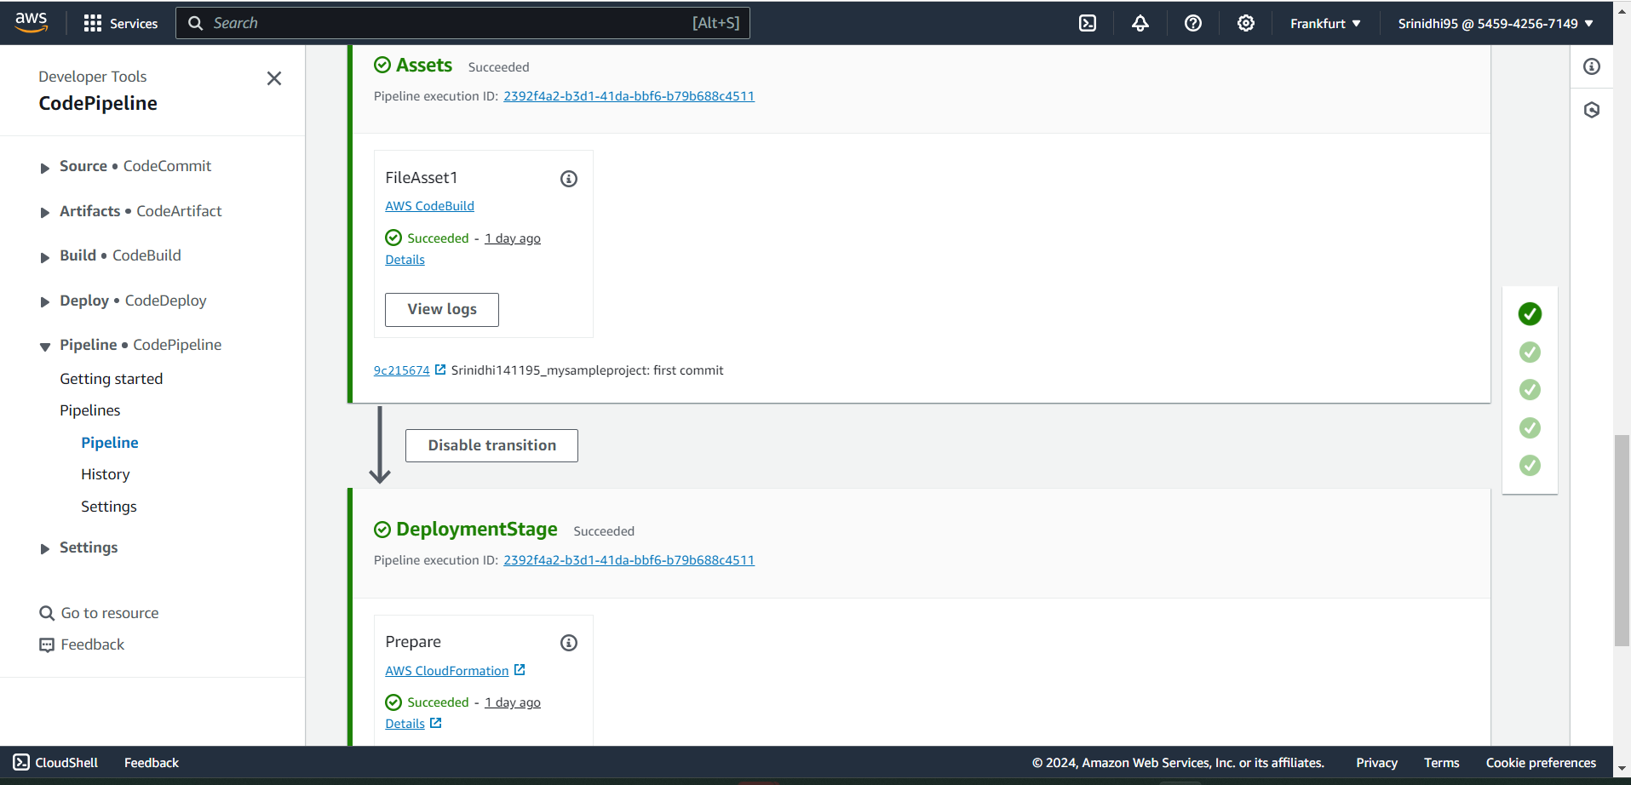

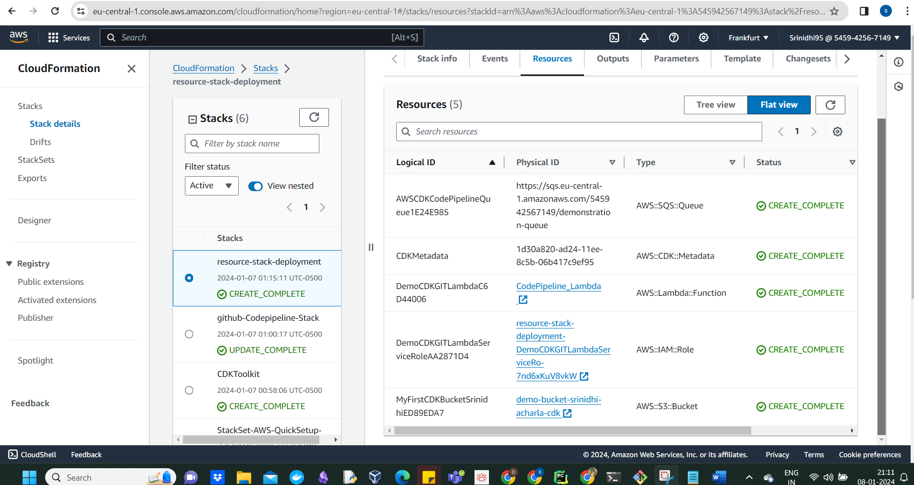

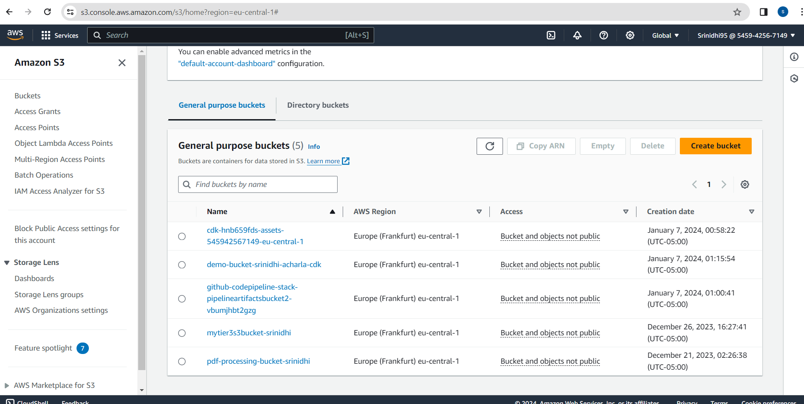

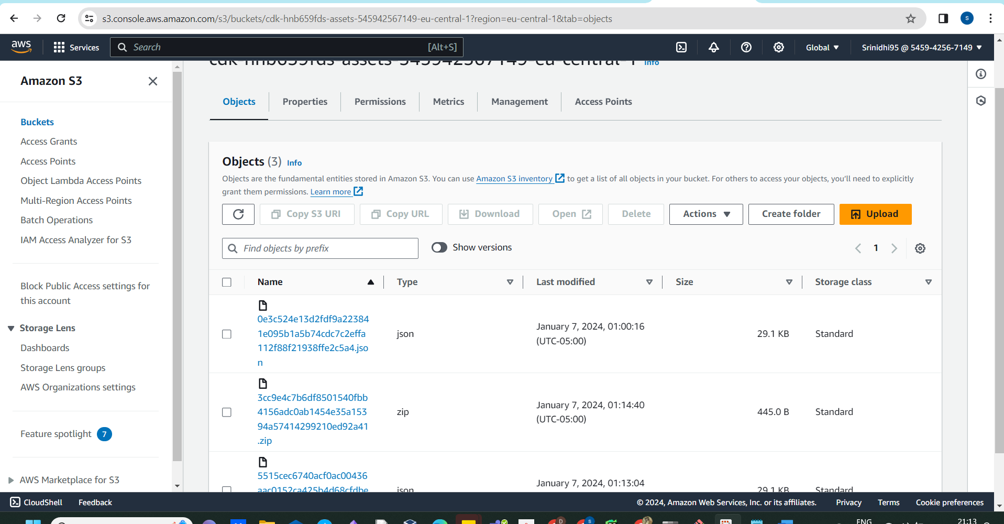

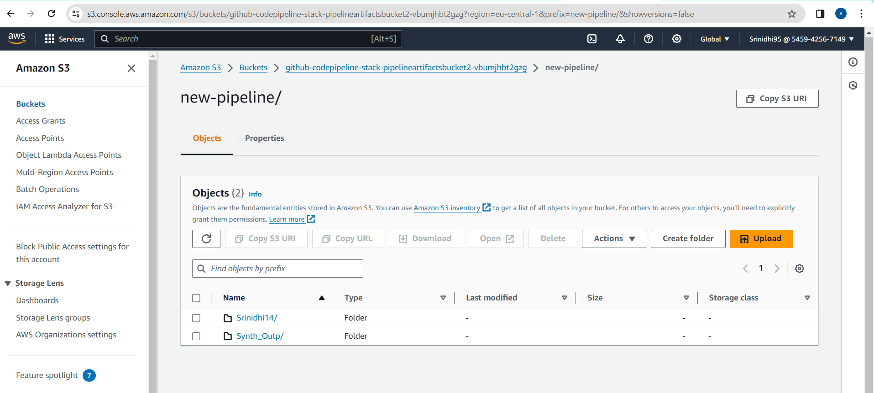

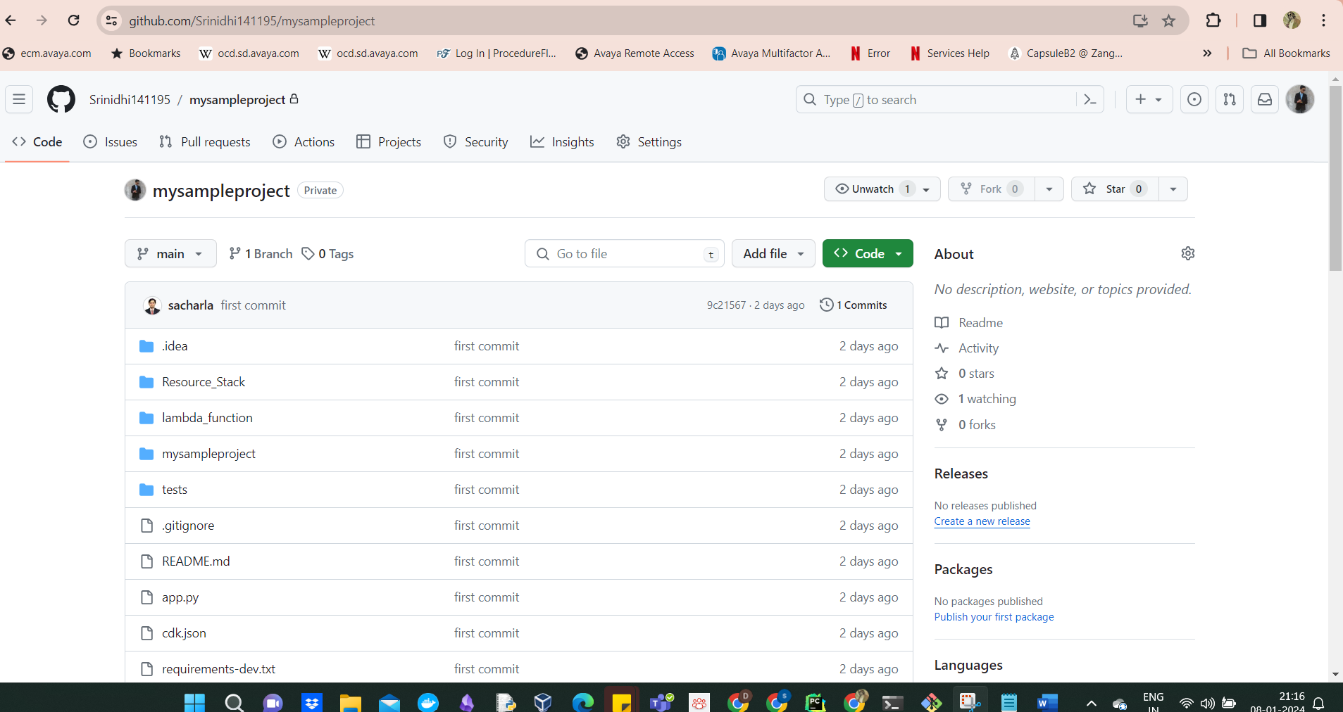

<https://github.com/Srinidhi141195/mysampleproject>